 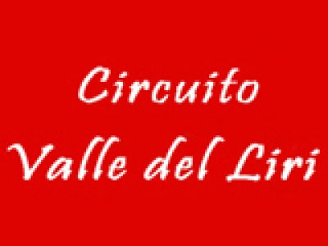

**PROGRAMMA PROVE LIBERE SABATO 16 OTTOBRE**

**INGRESSO DALLA PREGRIGLIA**

**MATTINA POMERIGGIO**

**09:00-09:10= 60 MINI + GR.3 14:00-14:10= 60 MINI + GR.3**

**09:15-09:25=** **60 ENTRY LEVEL 14:15-14:25= 60 ENTRY LEVEL**

**09:30-09:40=** **X30 (JUNIOR+SENIOR) 14:30-14:40= X30 (JUNIOR+SENIOR)**

**09:45-09:55=** **125 KZN UNDER+OVER 14:45-14:55= 125 KZN UNDER+OVER**

**10:00-10.10=** **125 KZN JUNIOR+KZ2 15:00-15:10= 125 KZN JUNIOR+KZ2**

**10:15-10:25= 60 MINI + GR.3 15:15-15:25= 60 MINI + GR.3**

**10:30-10:40= 60 ENTRY LEVEL 15:30-15:40= 60 ENTRY LEVEL**

**10:45-10:55= X30 (JUNIOR+SENIOR) 15:45-15:55= X30 (JUNIOR+SENIOR)**

**11:00-11:10= 125 KZN UNDER+OVER 16:00-16:10= 125 KZN UNDER+OVER**

**11:15-11:25= 125 KZN JUNIOR+KZ2 16:15-16:25= 125 KZN JUNIOR+KZ2**

**11:30-11:40= 60 MINI + GR.3 16:30-16:40= 60 MINI+ GR.3**

**11:45-11:55= 60 ENTRY LEVEL 16:45-16:55= 60 ENTRY LEVEL**

**12:00-12:10= X30 (JUNIOR+SENIOR) 17:00-17:10= X30 (JUNIOR+SENIOR)**

**12:15-12:25= 125 KZN UNDER+OVER 17:15-17:25= 125 KZN UNDER+OVER**

**12:30-12:40= 125 KZN JUNIOR+KZ2 17:30-17:40= 125 KZN JUNIOR+KZ2**

PAUSA PRANZO DALLE 12:40 ALLE 14:00